AWS MQ
Task Title : Create and Verify Amazon MQ Broker
Objective
Provision an Amazon MQ broker (ActiveMQ or RabbitMQ) with default settings and validate its availability by accessing the broker endpoint link provided in the AWS Console.
Prerequisites
- AWS account with access to Amazon MQ
- IAM user/role with permissions: mq:CreateBroker, mq:DescribeBroker, mq:ListBrokers
- A VPC with at least one (preferably two) private subnets for high availability
- Security group allowing broker ports (e.g., 5672 for RabbitMQ, 61616 for ActiveMQ) from application subnets
- Admin username and password for the broker
- Client application or tool supporting AMQP/JMS/MQTT to test connectivity
- Network access (VPN/Direct Connect/Bastion/EC2) to reach the broker endpoints

Step-by-Step Process
Create the Amazon MQ Broker (Console)
- Go to Amazon MQ in the AWS Console.
- Click Create broker.
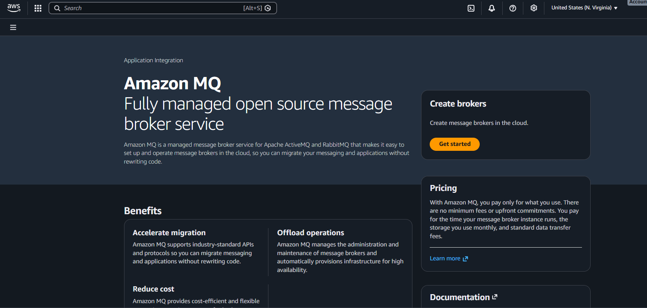
Choose Broker engine: ActiveMQ or RabbitMQ.
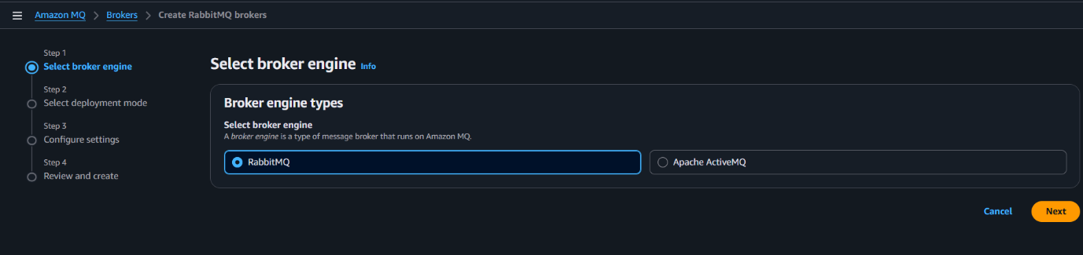

Select Deployment mode: Single-instance (dev/test) or Multi-AZ (production).
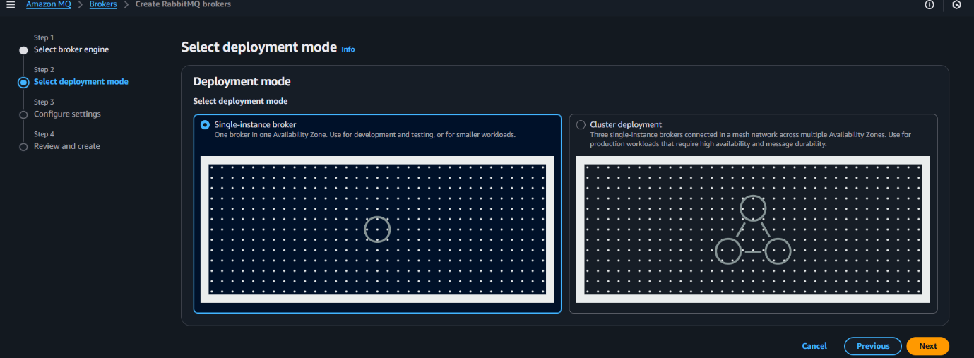
Configure:
- Broker name
- Instance type (default mq.t3.micro for dev)
- Storage (default)
- Authentication: Create a username/password for broker access
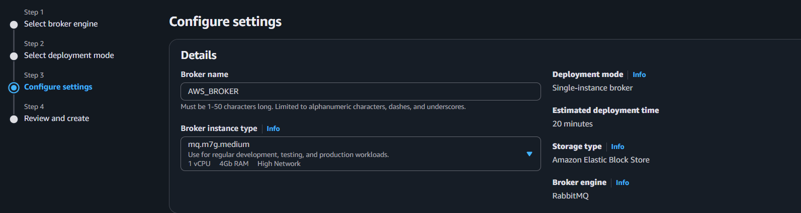
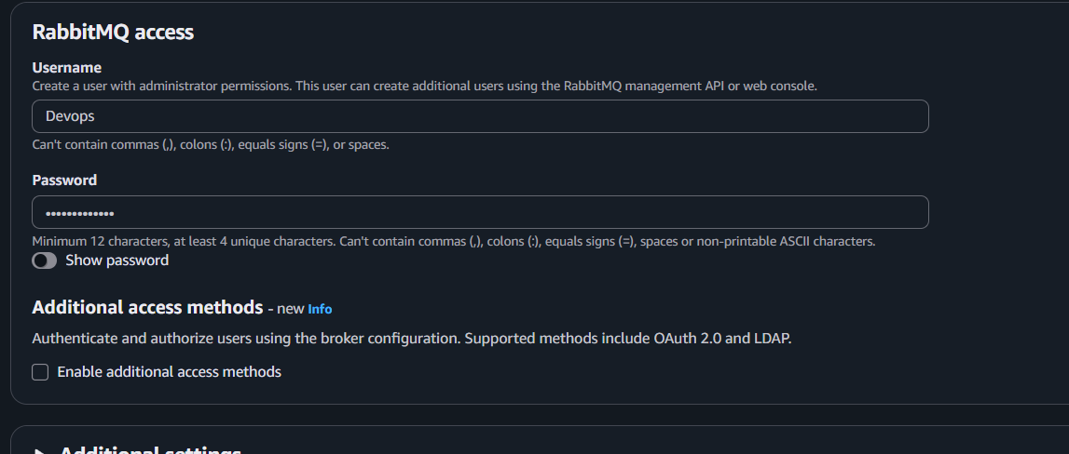
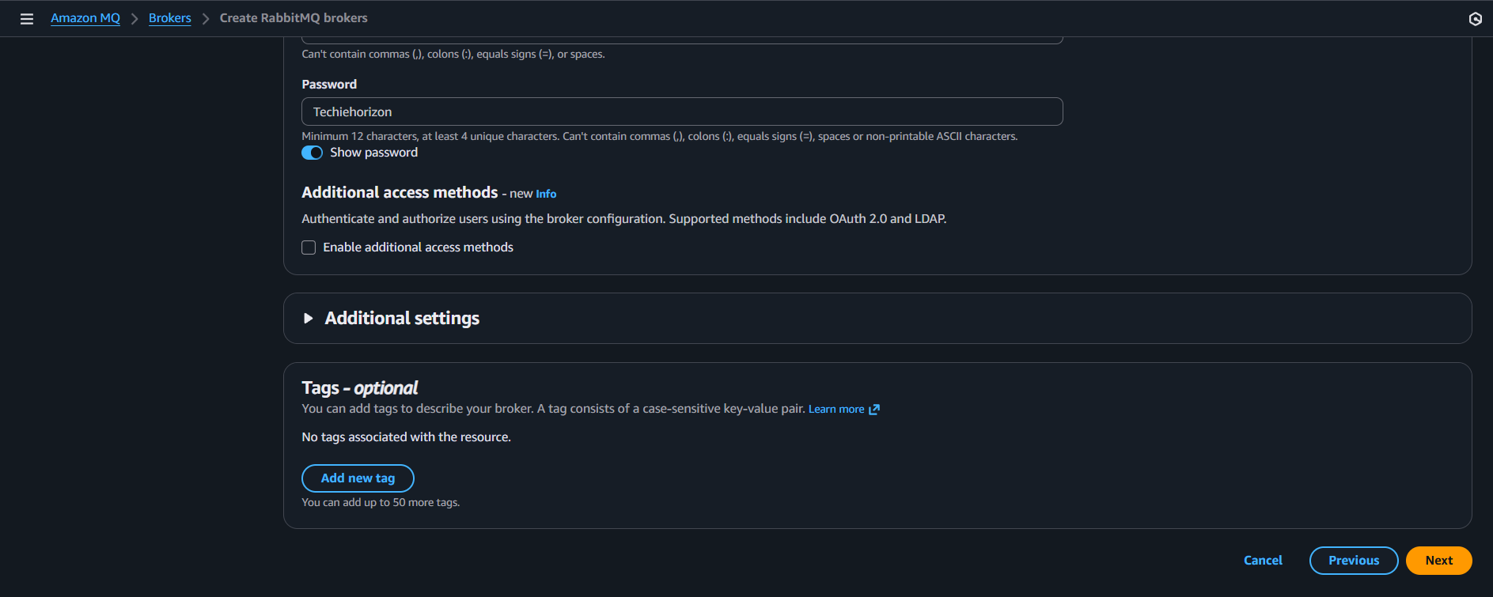
Review the details and create
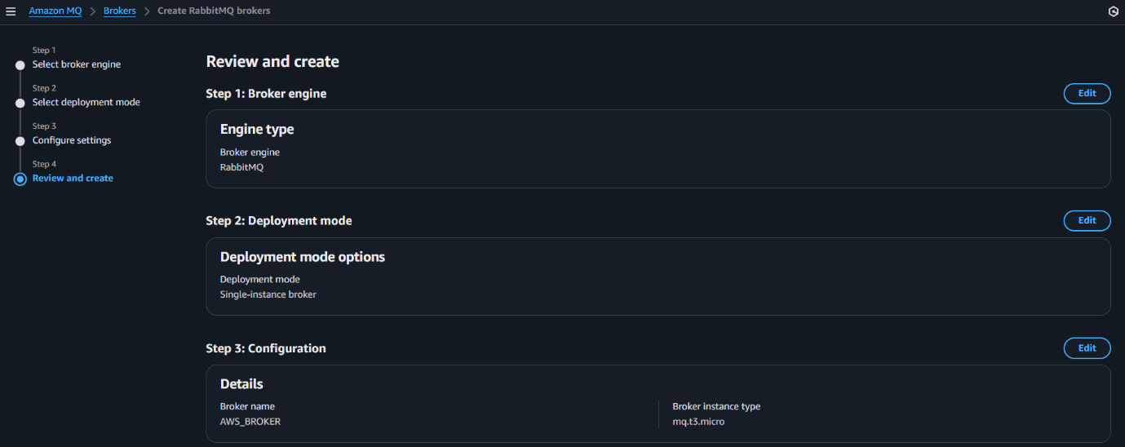
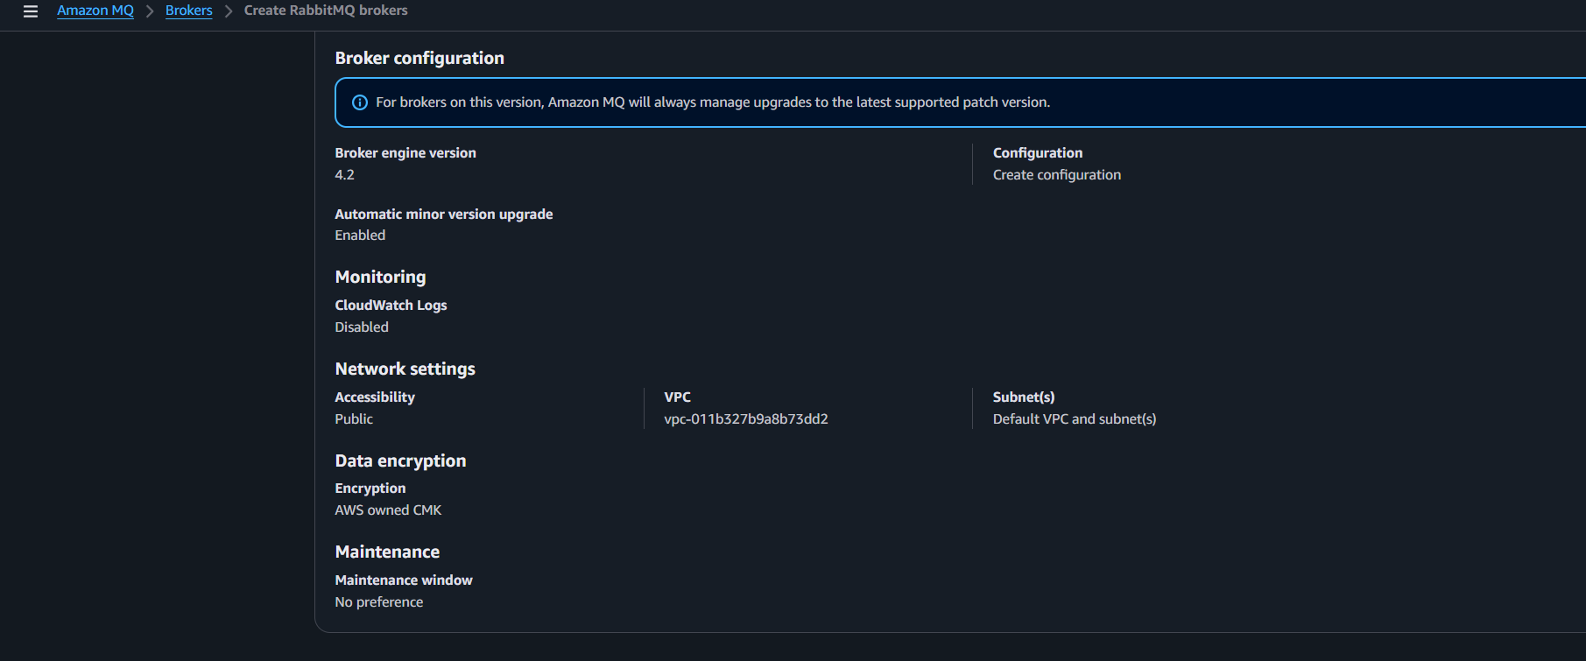

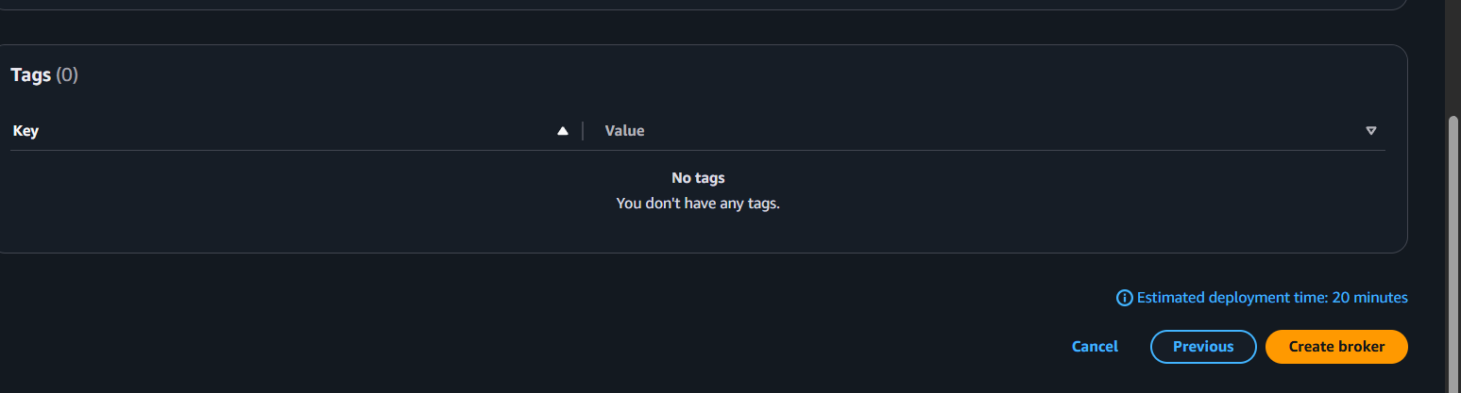
The service has been created
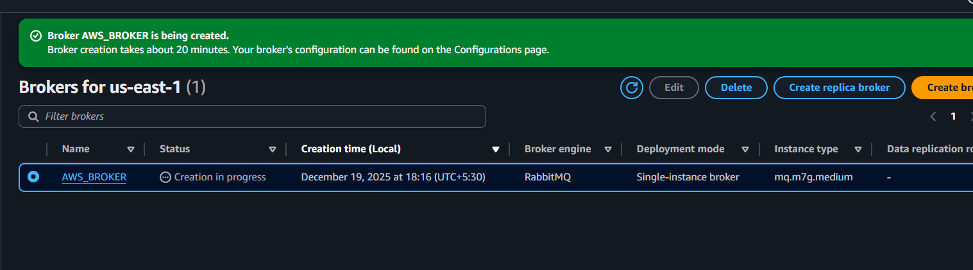
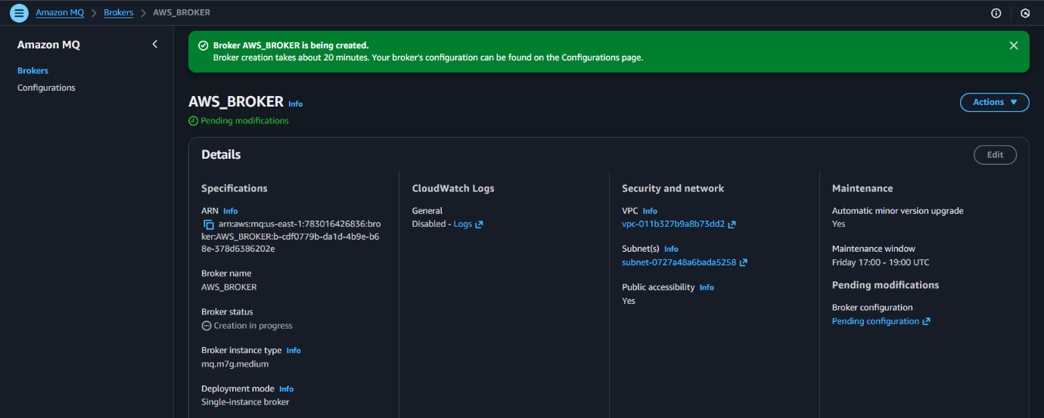
After 20 minutes the broker status will be changed then we can verify using the link,

We can check the configuration details by click on configurations and its history also
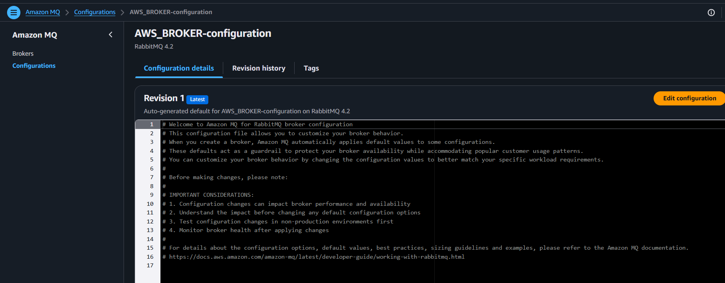
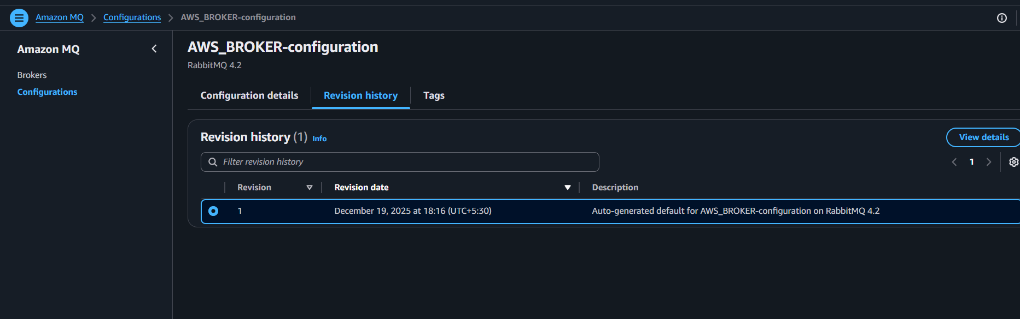
After sometime the status changed and now it running
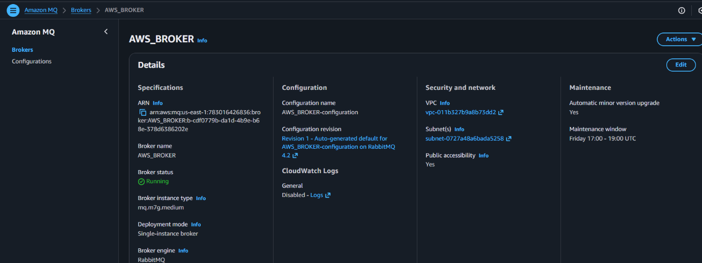
Lets verify
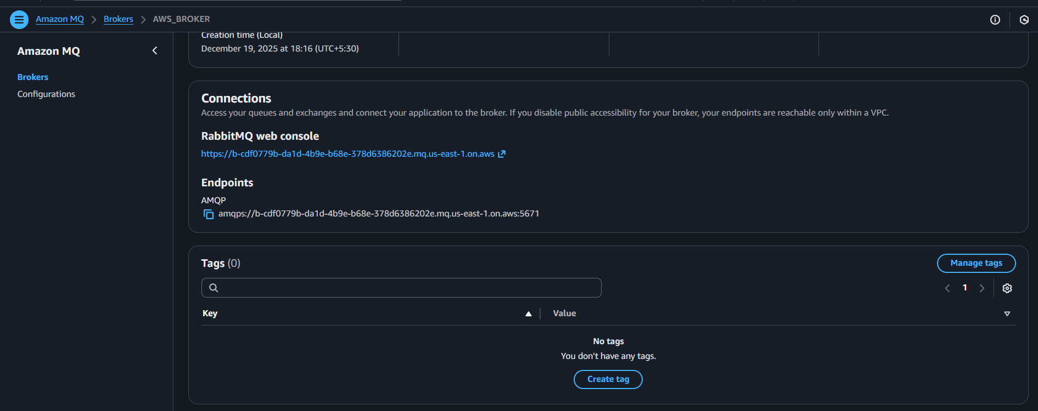
We need to provide username and password to login
The same which we provided while provisioning MQ
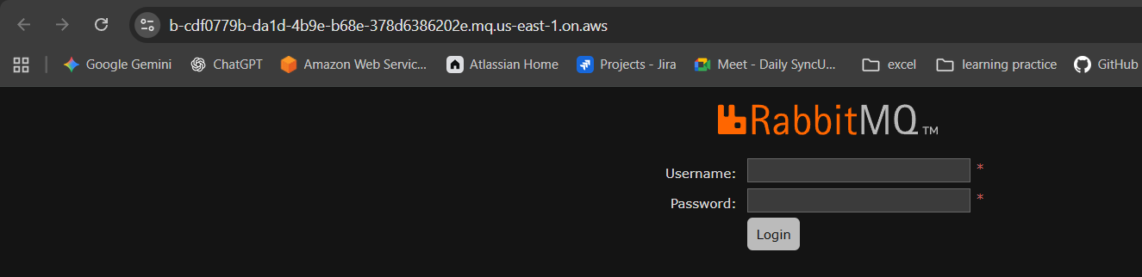
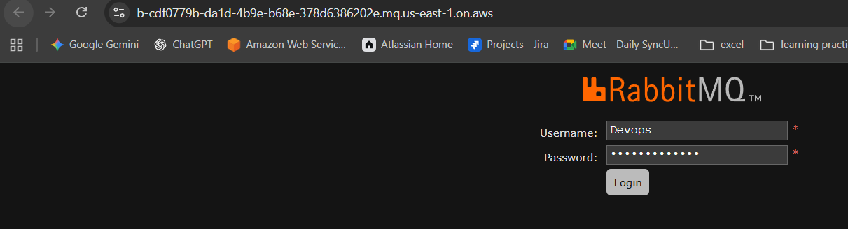
.

The overview tells that everything about storage, memory etc
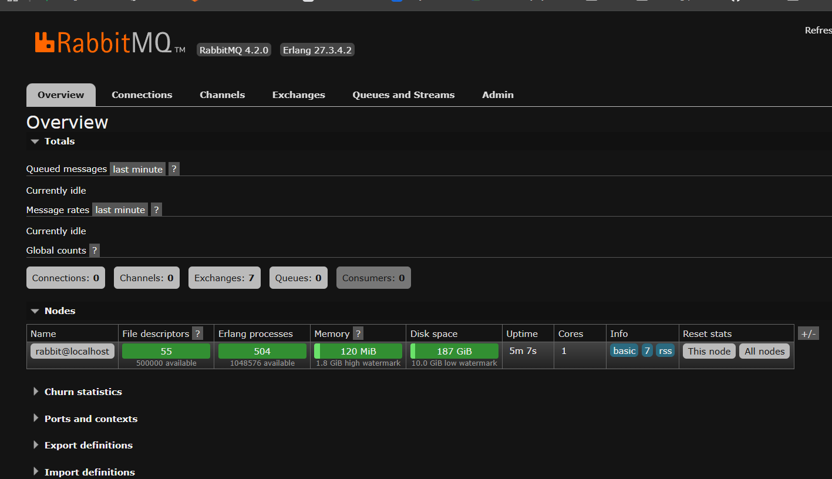
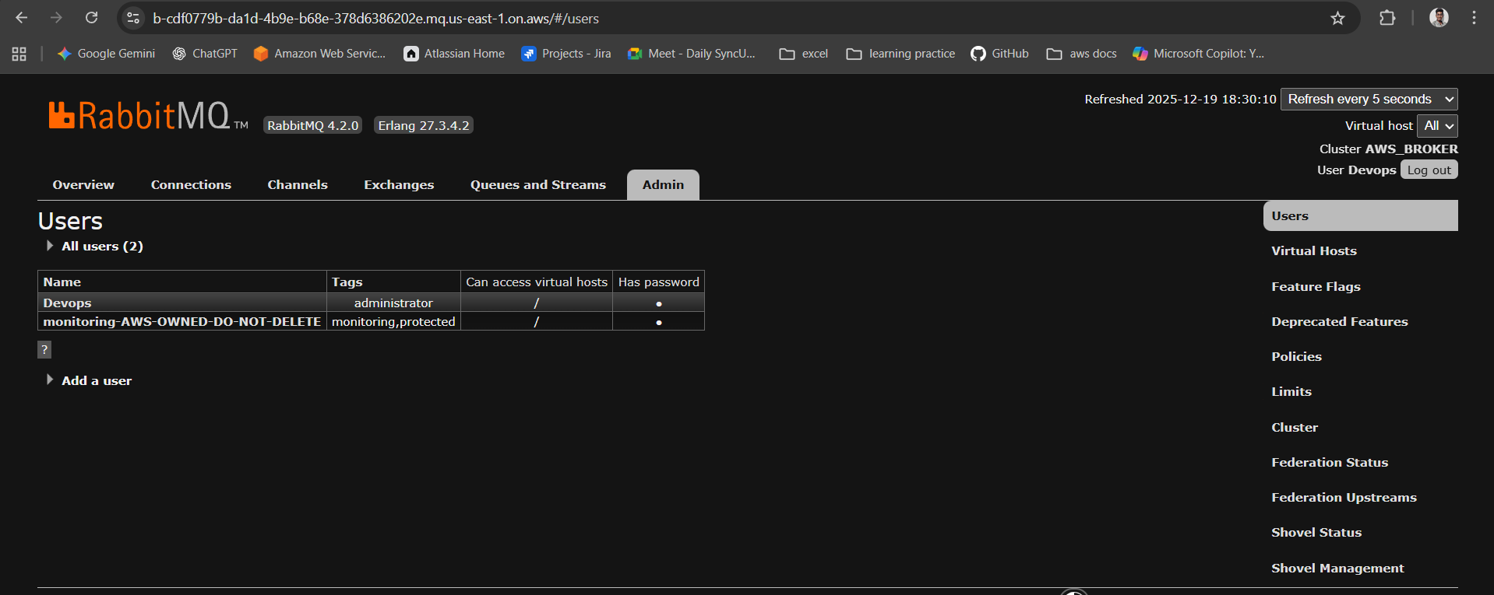

Conclusion
Creating and verifying an Amazon MQ broker provides a managed, highly available message broker for applications that require standard messaging protocols like JMS or AMQP. Successful verification ensures producers and consumers can reliably communicate, enabling smooth migration of legacy systems and dependable message-driven architectures on AWS.

